*1.Write a query to get all products based on designer and store?*

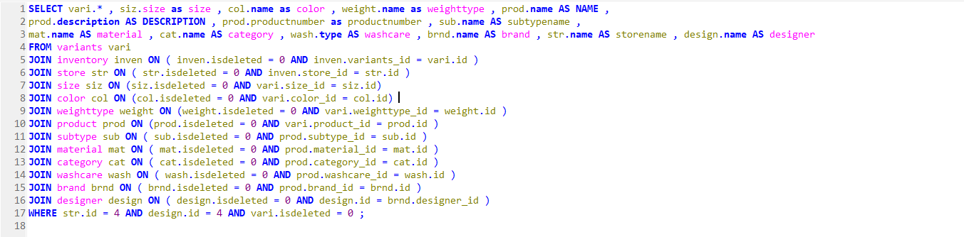

**

**

*2. Write a query to find order details that order details contains customername, orderid, orderdetailsid, totalprice, variant details, quantity, address and payment details based on designerid?*

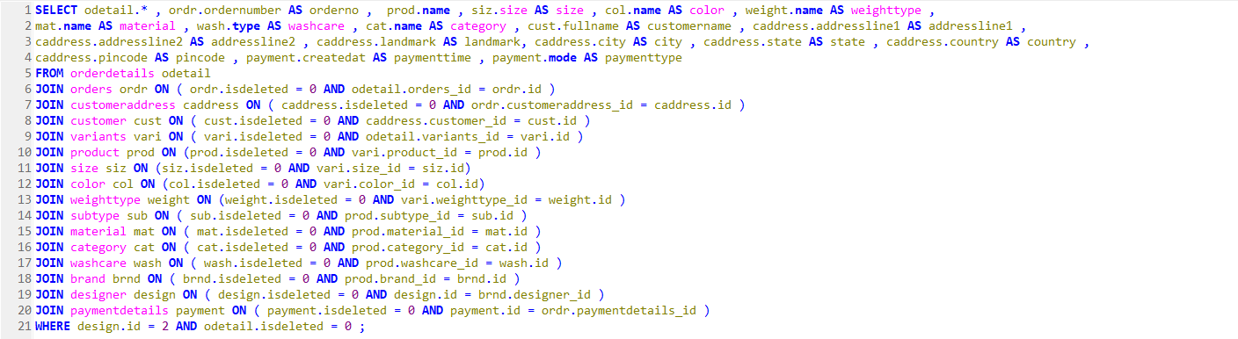

**

**

*3. Write a query to fetch the delivered orders of customer with corresponding order id ?*

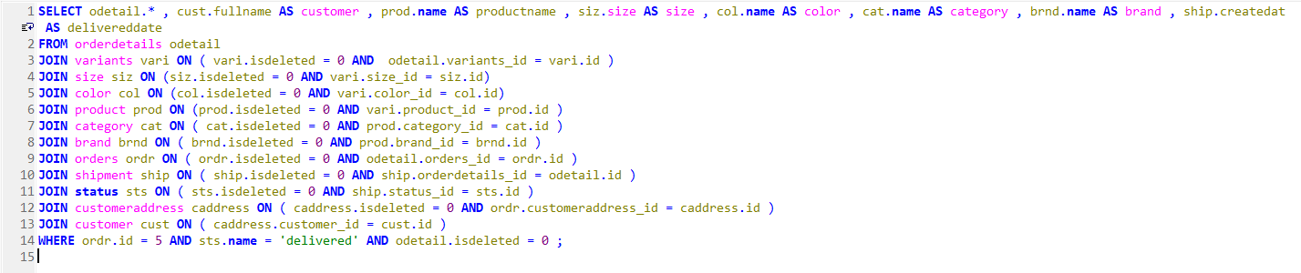

**

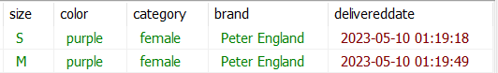

*4. Which customer has most orders ?*

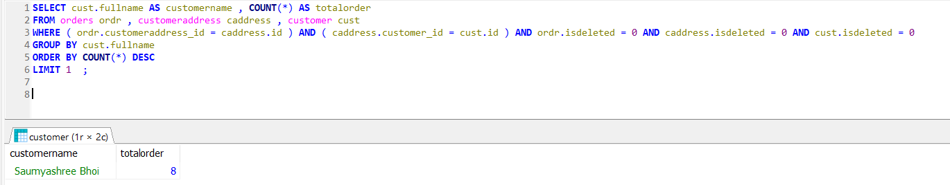

*5. What is the most selling product?*

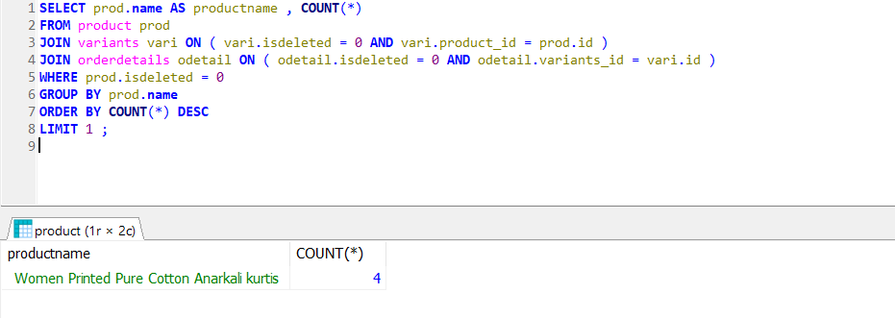

*6. Write a query to fetch all the customers who has more than 2 products in their cart ?*

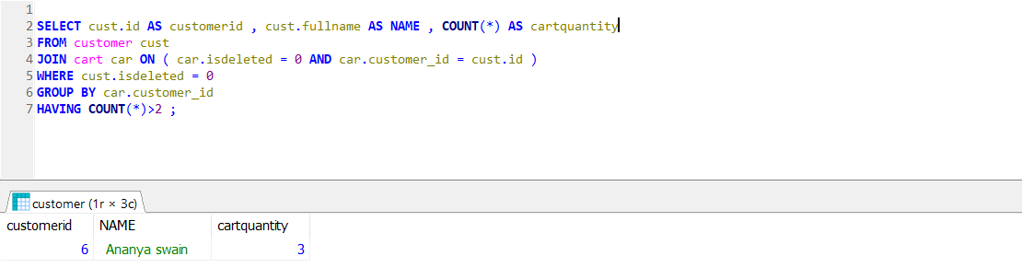

*7. Write a query to fetch all the product details which are colour blue and size L ?*

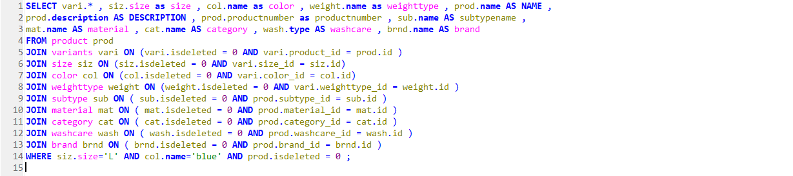

**

**

*8. Write a Query to fetch customer Details for Designer?*

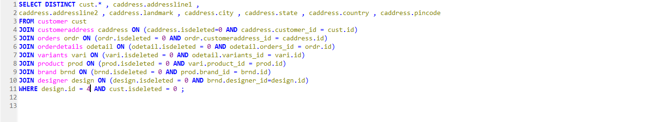

**

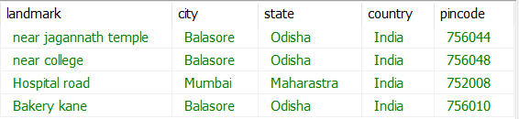

*9. Write a Query to fetch product details for Designer?*

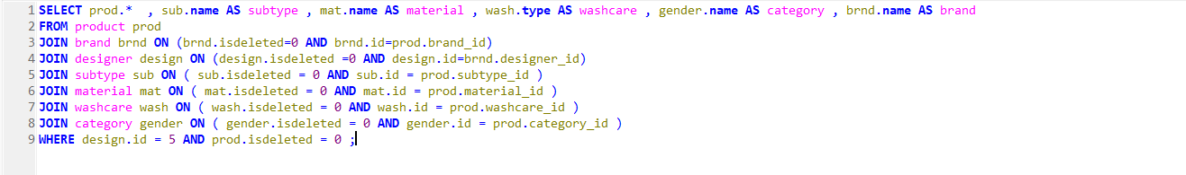



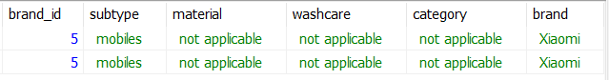

*10. Write a Query to fetch Order Details for customer?*

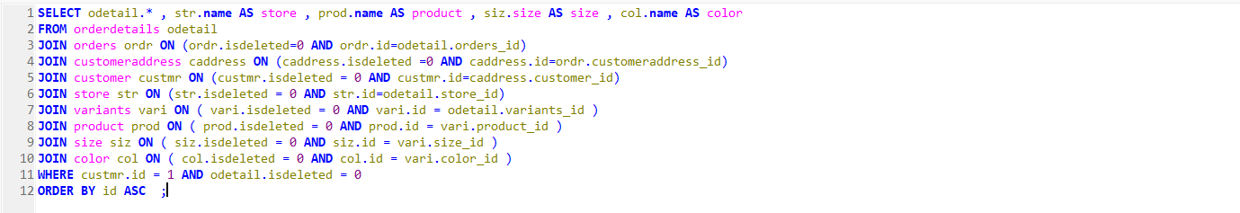

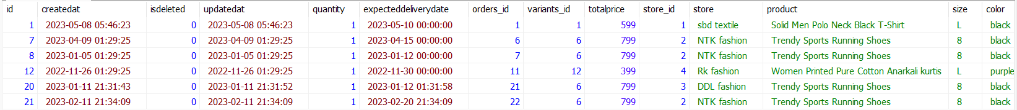

*11. Write a Query to fetch variants based on product?*

**Query-1**

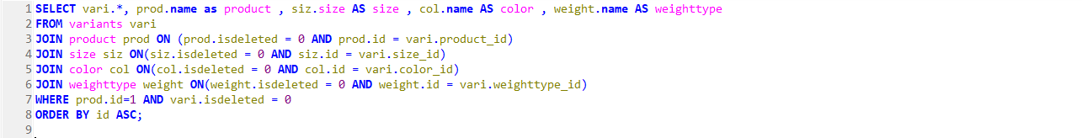

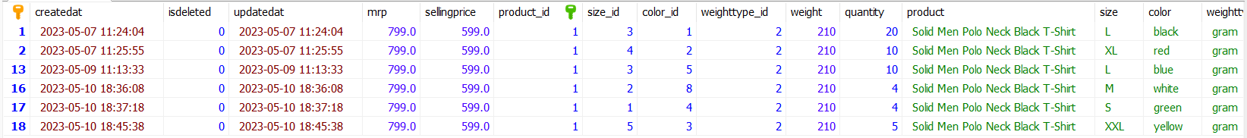

*12. Write a Query to search a product based on name?*

***QUERY - 1***

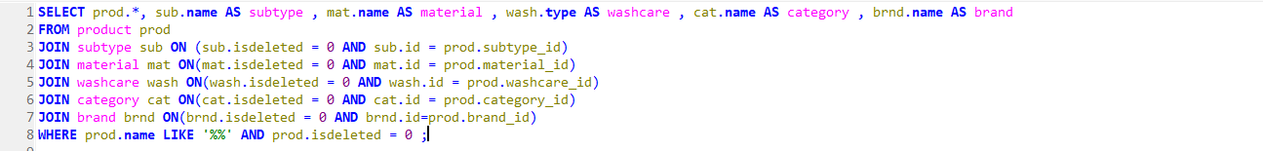

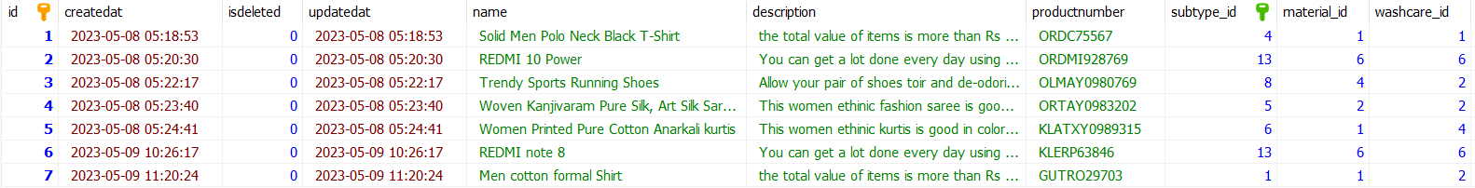

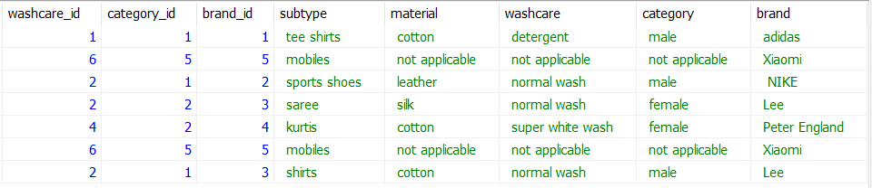

**QUERY-2**

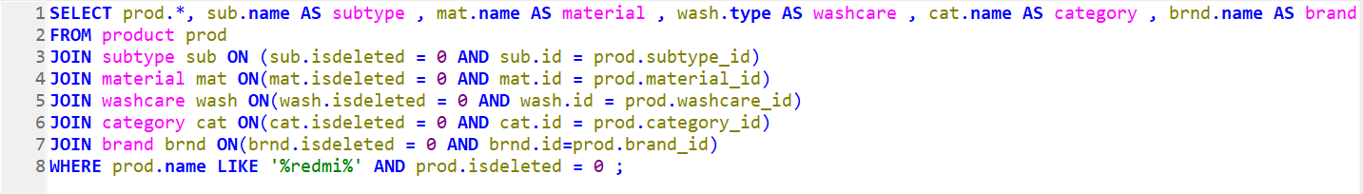



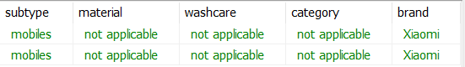

*13. Write a Query to get all order Details of customer for designer?*

***Response :*** *Order No**Product No**Order Id**Product Id**Order Status**customer Details**Order Details (if order status is delivered then order details should be present otherwise it should be null)*

*(Case when status.name =’delivered’ then orderdetails.id else null end) as orderid*

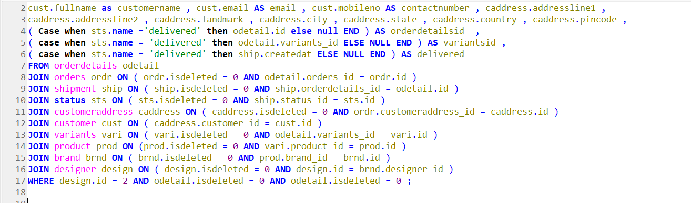

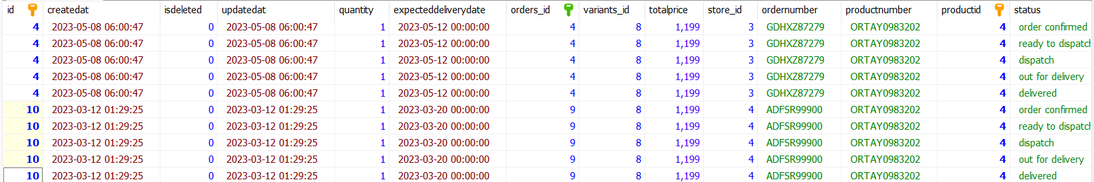

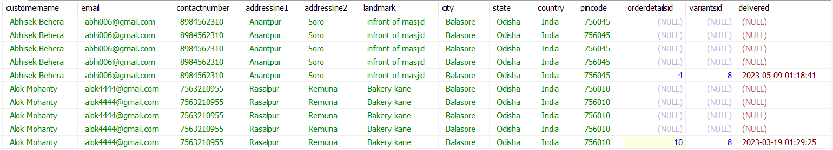

*14. Write a Query to fetch Product Details based on (Store Or Designer Or Both)?*

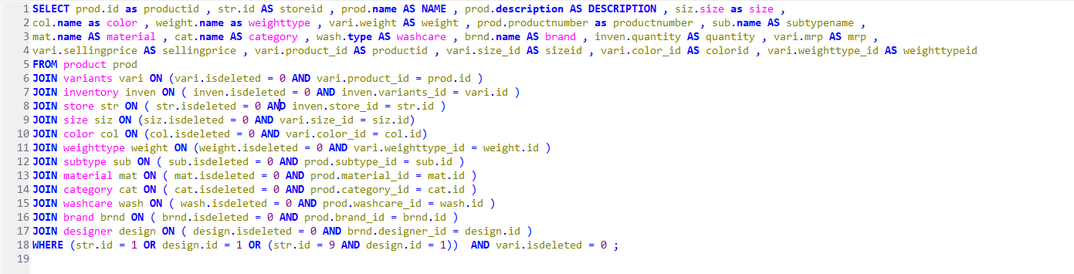

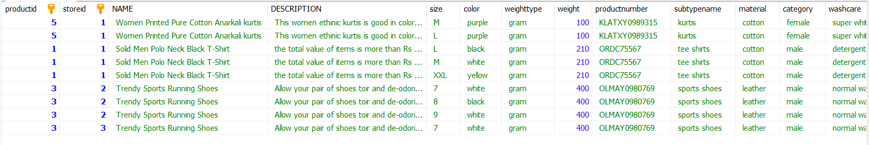

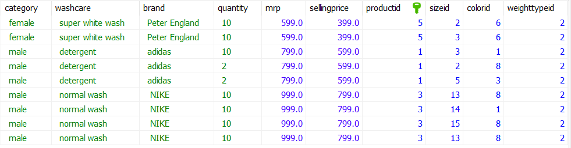

*15. Write a Query to fetch ratings and reviews based on customer Or Designer? (if customer id is present but review are not present)*

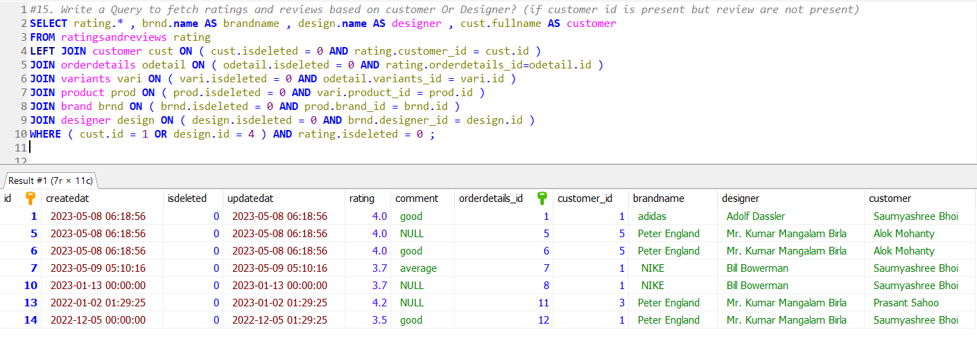

*16. Write a Query to update after 5 number rows, isdeleted = 1 for Order Details table?*

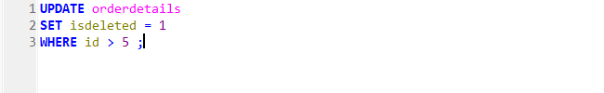

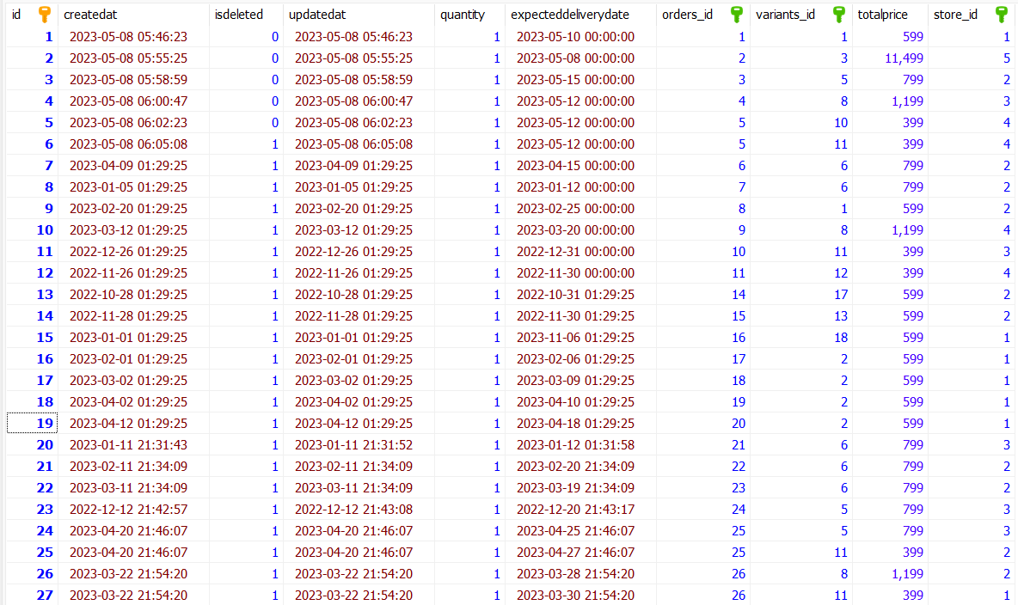

*17. Write a Query to fetch shipment all data based on store or designer?*

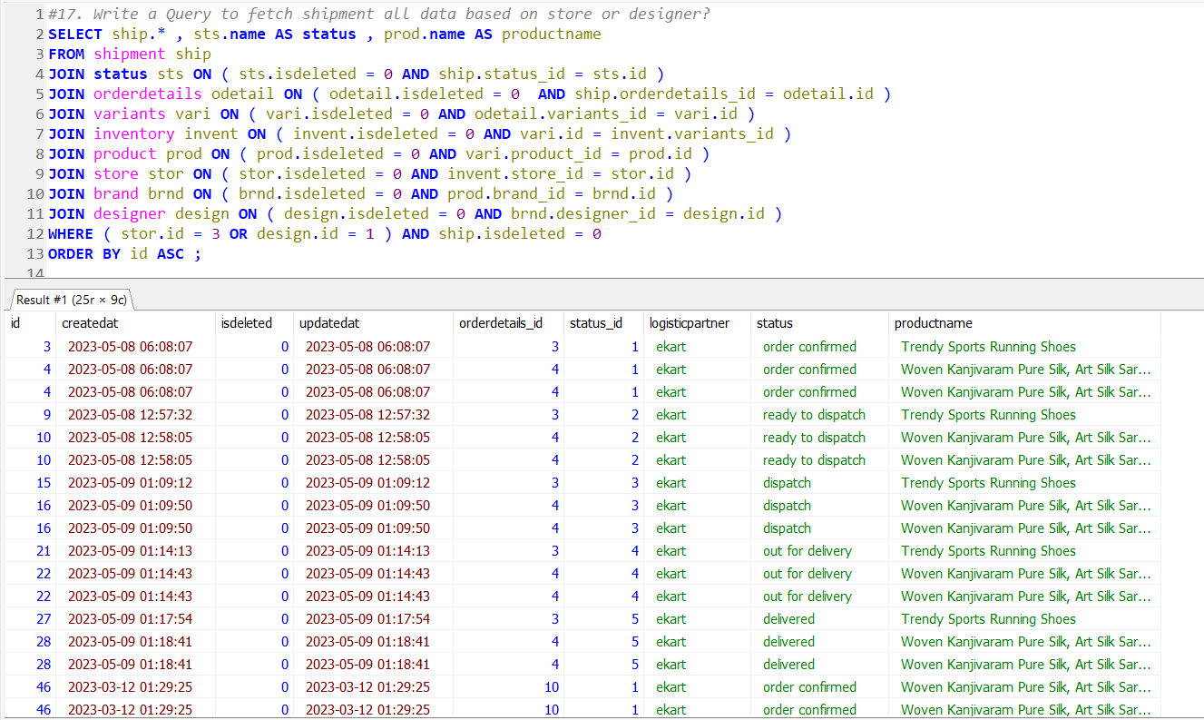

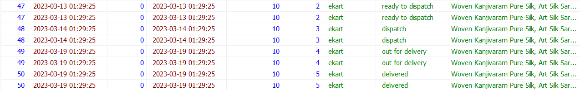

*18. Write a query to fetch the employees whose salary is greater than X (Raghab) and who works in store Y(sbd textile) and Brand Z(adidas) ? Put X, Y, Z according to your database?*

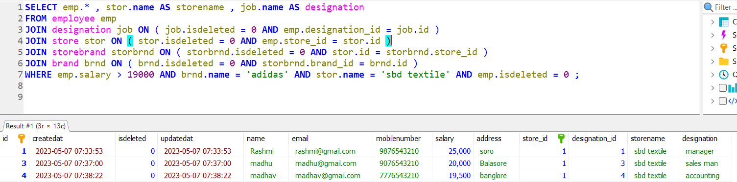

*19. Write a query to fetch the list of Store address details in the standard format.(Invoice address format.)?*

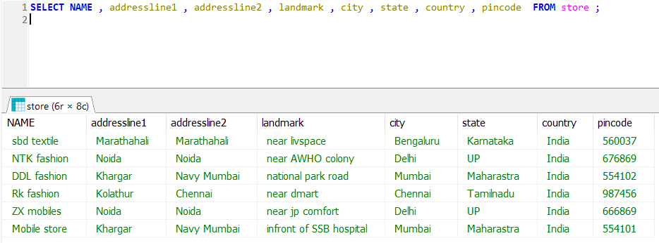

*20. Write a query to fetch the remaining quantity of the product which are sold?*

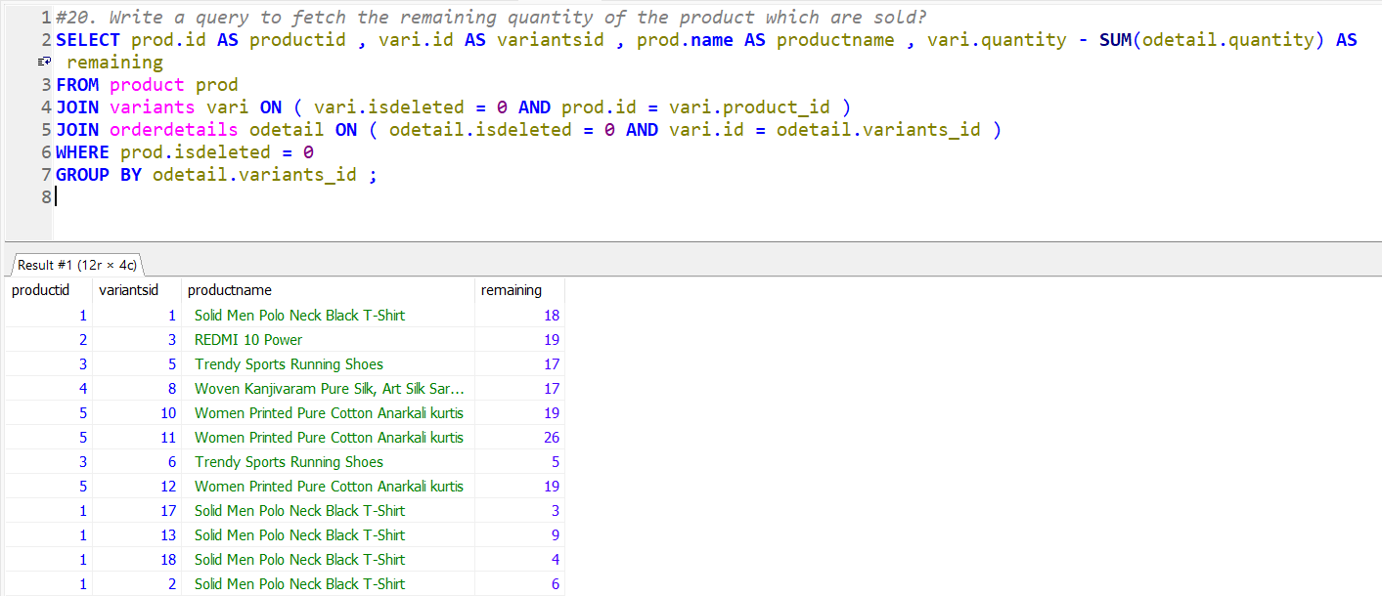

*21. Write a query to fetch the products which are in more than 5 variants?*

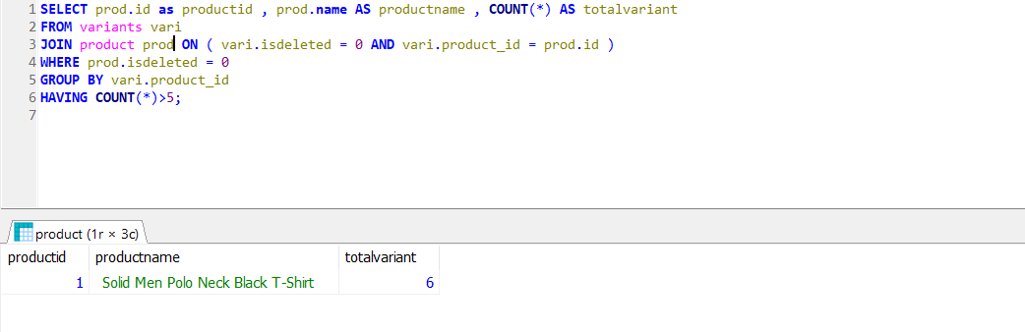

*22. Write a Query Trend of Top 5 selling variants over the past 6months?*

